October 15, 2024

A GREAT PLACE TO COLLABORATE: The Brookings Community continues to amaze me with the opportunities for collaboration and support within organizations.

- SDSU: Early Learning, Landscape and Design, Autism Consulting, Facilities, etc. These are a few specific areas that we have worked with SDSU to improve or develop. As our Early Childhood Play areas are near completion, our time with SDSU’s landscape and design team is coming to life. What started as a conversation between Dr. Crawford and me became an excellent area for our youngest learners. Jeremiah Bergstrom was onsite with his team this summer and even completed a tree inventory for our district. That information will be shared later this month, and it will assist us in budgeting and preparation for tree removal or treatment.

- The Boys and Girls Club is submitting a Department of Labor Workforce Readiness Grant to greatly expand the workforce readiness opportunities and resources available to BSD students at Bobcat Plains Academy. Jody Hernandez did the heavy lifting of the grant, and once again, partnership with the Club is finding unique opportunities for BSD students.

A GREAT PLACE TO LEARN: Fall 2024 Enrollment

 | Schools |  | Fall 2024 | Fall 2023 | Difference
 | Bobcat Plains Academy HS |  | 74.00 | *51 | 74.00
 | Bobcat Plains Academy MS |  | 4.00 | 0 | 4.00
 | Brookings Hi Sch |  | 979.20 | *1031 | -51.80
 | Camelot Intermediate School |  | 523.33 | 500.36 | 22.97
 | Dakota Prairie Elementary |  | 497.01 | 491.06 | 5.95
 | George S Mickelson Middle School |  | 781.70 | 776.36 | 5.34
 | Hillcrest Elem |  | 302.10 | 316 | -13.90
 | Medary Elem |  | 352.25 | 337.12 | 15.13
 | Grand Total |  | 3513.59 | 3455.90 | 61.69

A GREAT PLACE TO WORK:

- I’ve shared with staff that I believe every student deserves a teacher who is well-versed in the Science of Reading (SOR), but just as importantly, every teacher deserves proper training. Fortunately, our state has offered numerous training opportunities, and many Brookings School District staff members have participated. Most, if not all, of these training courses take place outside of contract hours, and they are rigorous and time-intensive due to the significance of the content.

At the district level, we’ve established a Literacy Team to provide support for literacy practices throughout our schools. Last Friday, educators had the opportunity to work with Katie Anderson and Sheila Mulder, whom we’ve contracted to offer structured training and resources as part of our ongoing efforts to align with the Science of Reading. Today, district administrators had their second book study course with Shelia and Katie to support SOR practices in their buildings.

- Keena Melville has been working with Brookings School District staff, supporting best practices for engaging students who live and learn in neurotypical ways. Last year, Keena collaborated with our administrators, and we are incredibly grateful to SDSU for allowing her to continue this valuable work in our district. This fall, Keena has observed inclusion and classroom practices in our Early Learning programs, and last Friday, she shared her observations and recommendations with us.
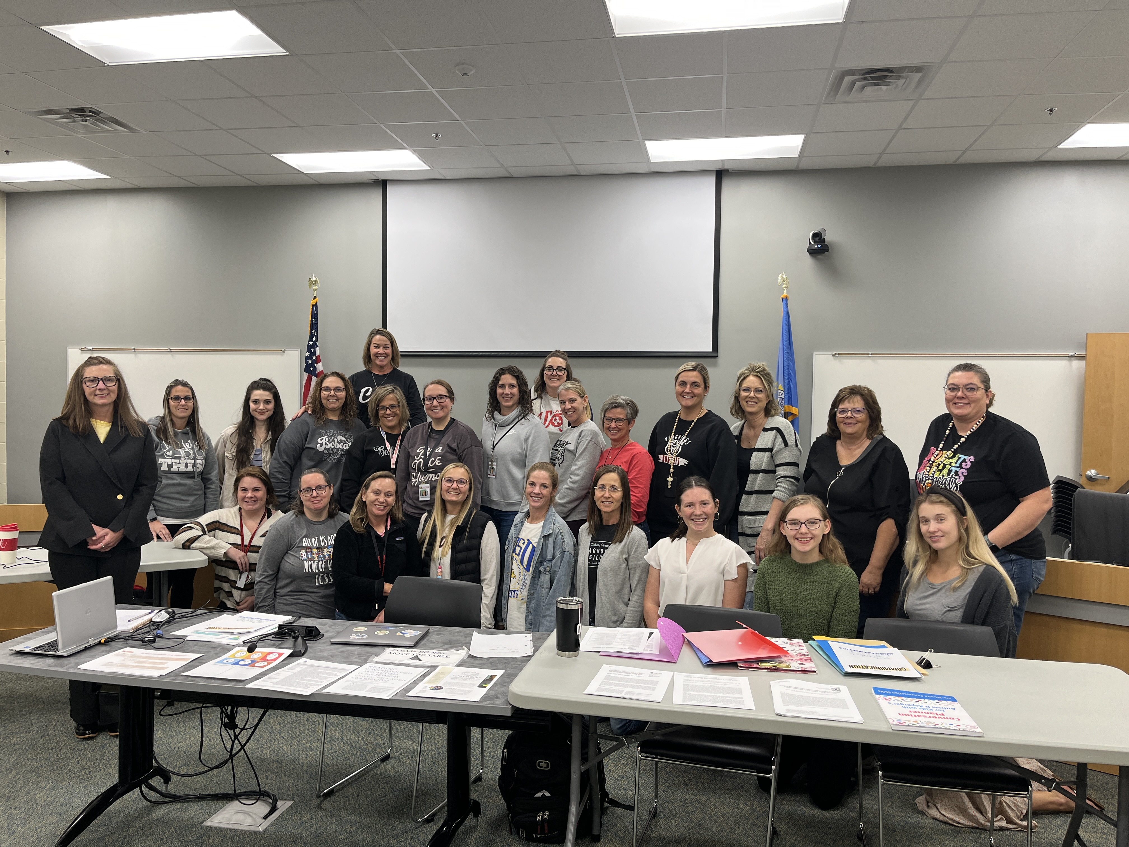

A RESPONSIBLE DISTRICT:

- BSD Facilities: Keith Fodness, BSD Facilities Director, provided updates on the work he’s been doing over the past month, but a big-picture look at the priority areas is included below:
  - 5th Street Gym: With the completion of two competition-size gyms in the new elementary buildings, the district is looking to eliminate the additional maintenance and annual upkeep associated with this facility. Although many users are in the gym each week, we must consider the district's current priorities and ensure that expenditures align. Committee and full board meetings have been used to strategize the best path forward, and the latest work came in the form of appraisal work and indoor air assessments. This information will be considered as it becomes available.
Inventory of Existing Facilities:
- Classrooms: Number, size, and types of science classrooms.
- Laboratories: Number, types (biology, chemistry, physics), size, and specialized equipment.
- Storage and support spaces.
- Technology and other equipment.
Utilization and Condition Analysis:
- Identification of Deficiencies and Needs
- Usage Rates: Frequency and types of classes held in each room.
- Condition: Age, wear, and compliance with current safety standards.
- Deficiencies: Structural issues, outdated equipment, and insufficient space.
Educational Specifications (Ed Specs);
- Vision and Goals for Science Education: Clearly describe (note: not design) the various learning activities to take place in these rooms.
- Space Requirements
- Safety and Accessibility Standards
- Storage Needs
- Equipment and Technology Needs
  - Microscopes, lab benches, gas, water lines, etc.
  - Smartboards, computers, scientific software, etc.
  - Science Area Renovations: We have spent considerable time discussing and planning for this area. Now that the architecture firm has been hired, the areas and development of educational specifications can be evaluated. Yesterday, many of our science teachers spent their day off working with the architects to begin this work. For reference, below is the outline of the work taking place:

